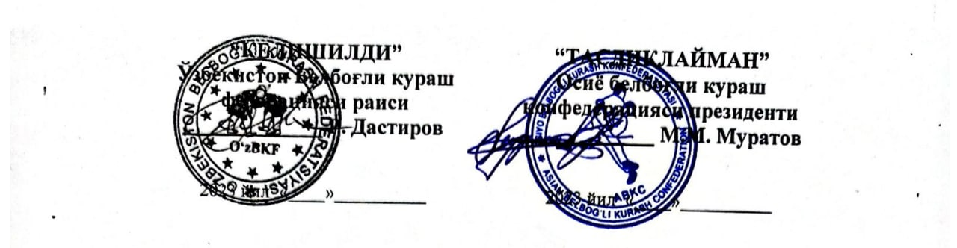

International Belbogli kurash Tournament as part of the International Ethnosports Festival
GUIDELINEL

Khiva city.(Uzbekistan) September 7-10, 2023

1. Organizing committee
The overall management of the competition is carried out by the Ministry of Youth Policy and Sports of the Republic of Uzbekistan, and the direct organization of the competition is carried out by the Belt Wrestling Federation of Uzbekistan.
2. Place and duration of the competition
The International Belt Wrestling Tournament will be held on September 7-10 at the "Ichan Castle" complex in Khiva.
3. Contestants
The organizing committee welcomes the foreign delegations at the international airport in Tashkent and Urgench, and the transportation throughout Uzbekistan, as well as the provision of food and accommodation for 1 head of the delegation and 1 trainer and two athletes are carried out by the organizing committee.
The expenses related to the participation of the remaining participants in the competition will be carried out by the sending organizations and the Asian Belt Wrestling Confederation.
Each official delegation must comply with the following content:
Sport type | Athlete | Referee | Coach | Leader | Total
Belbogli kurash | 5 | 1 | 1 | 1 | 8

4. Contestants
The competition will be held in the following weight categories according to the current rules approved by the Belt Wrestling Federation of Uzbekistan:
– Belbogli kurash (men): 75, 82, 90, 100, +100 kg
5. Visa
To get an entry visa, you need to fill out the application form and send it to the Organizing Committee with the participants' passports by August 1, 2023. You can get a visa at the nearest embassy of the Republic of Uzbekistan or an electronic visa.
6. Allocation
The winners and prize-winners will be awarded with the following prizes:
1st place - medal, diploma
2nd place - medal, diploma
3rd place - medal, diploma
7. Application
All applications for participation in the International Belt Wrestling Tournament should be sent to the Uzbekistan Belt Wrestling Federation by August 1, 2023:
Address: Uzbekistan, Tashkent city.
Phone: (+99891) 779 50-05, e-mail mail: rdastirov@mail.ru

Belbogli kurash within the ethnosport festival
International tournament

Khiva city.(Uzbekistan) September 7-10, 2023

Programme

September 7 2023 | – | Arrival of the delegations. Accreditation
September 8 2023 | 10:00 – 12:00 | Judges' Instruction
September 8 2023 | 16:00 – 17:00 | Mandate commission meeting
September 8 2023 | 17:00 – 18:00 | Weighing athletes
September 9  2023 | 09:00 – 13:00 | Qualifying competitions
September 9  2023 | 13:00 – 14:00 | Break
September 9  2023 | 14:00 – 17:00 | Continuation of the competition
September 9  2023 | 17:00 – 19:30 | Final
September 9  2023 | 20:00 – 21:30 | Continuation of preliminaries  Final Block  Award Ceremonies
September 10 2023 | 12:00 | Departure of the delegations

Belbogli kurash within the ethnosport festival
International tournament

Khiva city.(Uzbekistan) September 7-10, 2023

ENTRY BY NAME

Country::
Team Leader:
Coach:
Referee:

 | Weight | Name, surname
belbogli kurash | 75 кг
belbogli kurash | 82 кг
belbogli kurash | 90 кг
belbogli kurash | 100 кг
belbogli kurash | +100 кг

Arrival and departure information
 | Place | Flight number | Date and time
Arrival
Departure

